

GRIFFITH EX SERVICEMEN’S CLUB

GAMING PLAN OF MANAGEMENT

Version | Date | Approved By | Next Review Date
1.0 | August 25 | Kahlia Miles | August 26

Contents
1. INTRODUCTION 3
2. CLUB SAFE MEMBER 3
3. OUR VENUE 3
4. OUR CUSTOMERS 4
4.2 Partial Self-Exclusion 5
4.3 Counselling Services 5
4.4 Welfare Checks 5
4.5 Signs of Problem Gambling 5
4.6 Voluntary Pre-Commitment 6
5. OUR TEAM 7
5.1 Staff Training and Awareness 7
5.2 Responsible Gambling Officer 8
5.3 Gambling Incident Register 8
5.4 Staff Gambling Policy 9
6. NSW LEGISLATION 9
6.1 Minors/Persons Under 18 Years 10
6.2 Financial Transactions 10
6.3 Venue Gambling Signage and Information 12
6.4 Player Activity Statements 14
6.5 Operating Hours 14
6.6 Gaming related licence conditions 15
6.7 Community Contributions 15
6.8 Venue Layout 15
6.9 Review of Griffith Ex Servicemen's Club’s Gaming Plan of Management 15
6.10 Local Liquor Licensing Police Contact Details 16
7. APPENDIX A – FLOOR PLAN 17
8. APPENDIX B – RECORD OF STAFF COMPETENCIES 18
9. APPENDIX C – RECORD OF GPOM ACKNOWLEDGEMENT 19
10. APPENDIX D – LIQUOR LICENCE 20

- INTRODUCTION
Griffith Ex Servicemen's Club is committed to responsible gambling and as such have developed a plan of management in consultation with Griffith Ex Servicemen's Club board and management team to promote responsible service and delivery of gambling products.
This plan highlights our current initiatives and support services that are available to our customers and team to improve the overall standard of customer care and encourages a responsible gambling culture.

This Gaming Plan of Management has been adopted at:
Griffith Ex Servicemen's Club (LIQC300240096)
12 Jondaryan Avenue, Griffith NSW 2680

A copy of this document can be found on the Club website and in-house upon request at the main bar.

Griffith Ex Servicemen's Club is located in the SA2 of Griffith (NSW), which at the time of updating is a Band 3 and is licenced to operate 149 gaming machines. There are currently 149 EGMs in operation.

For more information, please email gaming@exies.com.au

- CLUB SAFE MEMBER
Griffith Ex Servicemen's Club are a member of Club Safe which is the club industry’s leading best practice and preferred responsible gaming program in NSW. It is based on a Multi-Venue Self-Exclusion (MVSE) program designed to assist people with a gambling problem by self-excluding them from multiple venues around which they live, work and socialise.

- OUR VENUE
Griffith Ex Servicemen's Club has an electronic gaming system installed which allows for the reporting of meters in fifteen minutes increments and gives management visibility of activity occurring on each gaming machine throughout the day.

Griffith Ex Servicemen's Club has CCTV cameras located at the entrance to the venue, the entrances to the gaming floor and throughout the gaming floor.

Griffith Ex Servicemen's Club offers a loyalty rewards program in-venue. This rewards program allows members to earn points for purchases in all areas of the Club as well as for gaming machine play.

A player reward scheme means a system, used in connection with the operation of gaming machines at a hotel or club, in which players of gaming machines accumulate bonus or reward point from playing the gaming machines.
A promotional prize means prizes or rewards (including bonus points) offered by the hotel or club to their patrons in connection with a player reward scheme or any other marketing or promotional activity that involves gaming machines. A hotel or club must not offer or permit promotional prizes:
• in the form of cash
• that exceed $1,000 in value
• that are indecent or offensive (including free giveaways), or
• to be exchanged for cash.
You must not allow bonus or reward points accumulated under a player reward scheme to be redeemed for cash.
Player activity statements
If you conduct an electronic player reward scheme or provide player account cards, you must let your player reward scheme participants and account card holders know that player activity statements are available.
If requested, you must provide them with a monthly player activity statement free of charge. Monthly activity statements must include:
• the player’s total amount of turnover, total wins, and net expenditure
• total points earned and redeemed as the result of playing gaming machines
• the total length of time during which a participant’s player card was inserted in gaming machines during each 24-hour period in the month, and the total length of time during the whole month
• a note advising that the statement only relates to the gaming machine play while the player’s card was inserted into the machine
• GambleAware information: ‘Help is close at hand. Call GambleAware 1800 858 858 or visit the GambleAware website’ You must keep a record or copy of any player activity statement made available to patrons. You must only disclose information in a player activity statement to:
• The person to whom the information relates, or Persons lawfully entitled to have access to the information.

- OUR CUSTOMERS
The decision to gamble lies with the individual and represents a choice, and in order to properly make that choice individuals must have the opportunity to be informed.
Griffith Ex Servicemen's Club is committed to providing appropriate information to all individuals including those from different cultural and linguistic backgrounds, so they are able to make informed decisions consistent with their personal preferences and individual circumstances.
Griffith Ex Servicemen's Club takes the issue of responsible gambling very seriously and actively promote the following initiatives to ensure all patrons to our club are aware of such services available to them.

  - Self-Exclusion
The ClubSAFE Multi-Venue Self-Exclusion (MVSE) Program is an online system designed to enable people with a gambling problem to self-exclude from our venue as well as multiple venues around where they live, work and socialise. Griffith Ex Servicemen's Club will initiate self-exclusion when requested by a patron at any time during its open hours.
The ClubSAFE MVSE Program removes barriers for people with a gambling problem such as the difficultness of visiting multiple venues or the embarrassment of visiting their local club to place the exclusion and makes the process easier for a person with a gambling problem. A patron can self-exclude by speaking to a duty manager at the club or by contacting a gambling help counsellor.
The minimum period for a self-exclusion is six months. Once a patron agrees to stay away from the club for a specific time, our venues have processes in place to help them honour that commitment. If a patron breaches their self-exclusion, it is reported through the MVSE program for assessment by trained counsellors. Griffith Ex Servicemen's Club is considering procuring facial recognition technology to assist in identifying self-excluded patrons entering the premises.

Griffith Ex Servicemen's Club has an electronic sign in system at reception which assists with identifying and preventing breaches of self-exclusion.

  - Partial Self-Exclusion
A partial self-exclusion allows a patron to exclude themselves from gambling activities at the club such as TAB/KENO and/or gaming machines, but still allows them access to other club facilities including restaurants, bars and other entertainment
A patron can self-exclude by speaking to a duty manager at the club or by contacting a gambling help counsellor.
The minimum period for a self-exclusion is six months. Once a patron agrees to stay away from the gaming activities of the club for a specific time, our venues have process in place to help them honour that commitment.
If a patron breaches their self-exclusion, it is reported through the MVSE program for assessment by trained counsellors.

  - Counselling Services
As required by law, Griffith Ex Servicemen's Club display problem gambling brochures at critical points within the venue and have a wide range of these brochures in many languages to help with our culturally diverse community. These brochures contain details about the ClubSAFE Counselling Service and Gambling Help Line:

ClubSAFE Counselling Service – 1800 997 766
GambleAware Helpline – 1800 858 858

The management team at our venue are proactive in handing out the relevant information to patrons in need. Griffith Ex Servicemen's Club will display information about local support services in strategic locations, like the bathroom, gaming floor and on digital displays.

  - Welfare Checks
Griffith Ex Servicemen's Club aims to ensure all our patrons have a positive experience this includes undertaking welfare checks on any guests who may be at risk of problem gambling. Our management and frontline team are vigilant in monitoring our patrons undertaking any gambling activity. If they are showing signs of extended play or distress, a duty manager will conduct a welfare check to gauge their mood, stress level and assertiveness and if required undertake the steps necessary whether that be encouraging them to take a break, explaining our exclusion or counselling services or asking them to leave the environment.
All encounters are recorded in our gaming incident register.

Indirect interactions such as daily announcements are made over the Clubs PA system to encourage customers to take regular breaks from gaming machines. Such announcements are regarding other events, promotions or services (such as courtesy bus departures) that are underway.

After midnight, welfare checks as well as direct and indirect interactions with customers will be increased to provide more opportunities for breaks in play and assessing the welfare of the patrons engaging in gambling activities after midnight.

  - Signs of Problem Gambling
Some of the signs of problem gambling are listed below. Staff are to remain vigilant in detecting any of the indicators mentioned below whilst on duty. If uncertain whether a patron is exhibiting any of the signs of problem gambling, the staff member is encouraged to speak with the duty manager and/or the Responsible Gambling Officer.

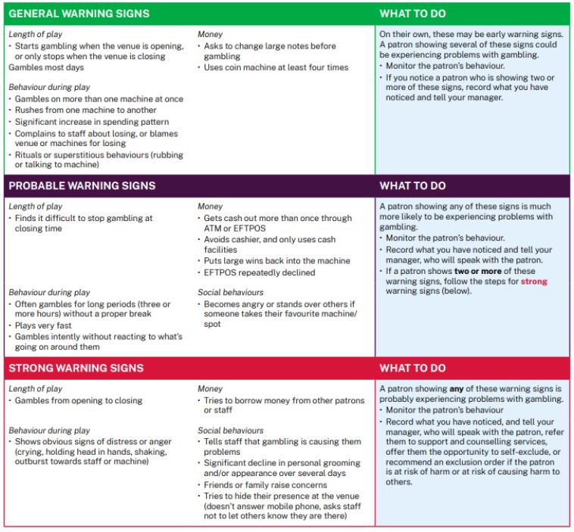

At-risk Gambling Behaviour is gambling behaviour that leads to gambling harm because it involved:
• Spending more money on gambling than a person can afford based on their income and financial commitments: and/or
• Spending so much time on gambling that it interferes with the person’s relationships, social life and/or work responsibilities

Gambling Harm refers to difficulties or other negative consequences that result from excessive gambling and affect the wellbeing of the person and/or their loved ones in many areas of their daily lives. Gambling harm can affect people’s physical and mental health as well as their financial wellbeing, relationships, education and employment, social and psychological wellbeing.

All staff are encouraged to discuss instances of at-risk gambling behaviour with a Responsible Gambling Officer, Duty Manager/Supervisor, or other Senior Staff Members.

  - Voluntary Pre-Commitment
Griffith Ex-Servicemen’s Club offer voluntary pre-commitment through the Ebet Gaming System. Voluntary pre-commitment allows members to set themselves a limit when using their membership card on gaming machines, this will then alert and lock the member out of further carded play once they reach their daily pre-commitment limit.

- OUR TEAM
Griffith Ex Servicemen's Club are committed to facilitating staff training so that we can continue to improve the way we provide a responsible environment for gambling and customer care. Our staff regularly undertake in-house training and refreshers on our policies and procedures.

  - Staff Training and Awareness
Griffith Ex Servicemen's Club employees undergo regular Responsible Conduct of Gambling (RCG) training to equip them with the skills and knowledge to identify the signs of risky and problematic gambling behaviour and assist problem gamblers.

In addition to the mandatory RCG training, team members undergo training sessions appropriate to their role:
Multi Venue Self- Exclusion
Advanced Responsible Gambling Training
Compliance Officer Training

These training sessions are vital in keeping our team up to date with industry updates, legislation and most importantly methods to ensure we are adhering to customer care and making it clear to staff that patron welfare is of the utmost importance.

Such training sessions give our team the forum to discuss and establish appropriate policies, procedures and lines of responsibility to provide customer care. These include house policies, clear accountability, reporting mechanisms and follow up procedures for dealing with responsible gambling issues.

Non-gaming staff are required to complete induction to RCG training to ensure that every staff member in the venue is trained to respond appropriately to any customer seeking help or displaying signs of gambling harm.

The Board of Directors are required to complete RCG Oversight training to ensure that there is a structured top down approach to harm minimisation.

The Licensee, Responsible Gaming Officers and any staff employed to undertake the management of gaming machines are required to participate in Advanced RCG training.

Harm minimisation is discussed at all staff meetings, encouraging and recognising staff who are being proactive in recognising at-risk customers, ensuring that all staff understand that patron welfare is of the utmost importance.

Any additional information pertaining to harm minimisation on a daily basis, outside of information recorded in the gambling incident register, is communicated via internal team communications such as shift reporting, emails and online meetings. This ensures that any relevant handover information is passed on to the next person coming onto shift.

Appendix B provides a list of all staff competency records for RCG and ARCG. This list includes expiry date of these competencies and is reviewed monthly to ensure that staff remain current in their training requirements.

  - Responsible Gambling Officer
    - The Licensee shall ensure that one Responsible Gambling Officer, being a staff member who holds a current RCG Certificate and Advanced RCG Certificate, is on duty and monitoring the gaming machines of the venue whenever gaming machines are operating.
    - The Licensee shall ensure that one Nominated Responsible Gambling Officer, being a dedicated staff member who holds a current RCG Certificate and Advanced RCG Certificate, is on duty and monitoring the gaming machines of the venue at any time that the gaming machines are operating between the hours of midnight and 8am. Nominated RGO’s are permitted to perform gaming-related tasks that allow them to interact with, and monitor, gaming patrons.
    - The Responsible Gambling Officer’s escalation responsibilities include:
(i) Proactively check-in on and engage with patrons where the RGO suspects they may be experiencing gambling harm
(i) Record gambling Incidents in the Gambling Incident Register
(ii) Escalate serious instances of gambling harm to senior management
    - At all times, the Duty Manager or other senior manager responsible for gaming machine operations will assist the Responsible Gambling Officer in carrying out the duties described in this condition.
    - Responsible Gambling Officers may make complaints to Liquor & Gaming NSW about harm minimisation breaches at this venue or if they are impeded from undertaking their duties.

  - Gambling Incident Register
    - The incidents that must be recorded in a gambling incident register include:
a) a patron displays behaviour that indicates the patron is experiencing or at risk of gambling harm
b) a patron, or a person who identifies themselves as a family member of the patron, asks for information about a self-exclusion scheme or some form of intervention for the patron
c) a breach or attempted breach of a self-exclusion scheme
d) an offence, alleged offence or incident involving a minor 10
e) details of action taken in response to an incident mentioned in paragraph (a)–(d).

Behaviour that indicates someone is at risk of or experiencing gambling harm is at section 4 of this plan.

Incidents must be recorded as soon as practicable, but no longer than 24 hours after they happen.

A gambling incident register must be kept for three years and made available to police and inspectors. Griffith Ex Servicemen's Club is subject to the Privacy Act 1988 (Cth) and related Australian Privacy Principles in the collection and use of information for the incident register.
    - Griffith Ex Servicemen's Club keeps a physical incident register
    - The licensee is required to review the gambling incident register on a monthly basis and consider what harm minimisation actions can be taken in response to trends in the register.

  - Staff Gambling Policy
Griffith Ex Servicemen's Club have a staff gambling policy in place. The main objectives of this policy are:
• To foster a healthy environment for people who could be at risk of developing gambling problems;
• Patrons and guests perceive that the gambling operations of the club are being conducted in a fair and equitable manner
• To ensure the Club complies with its legal obligations

No staff member is permitted to use gaming machines at the venue during their hours of employment while on shift, including during breaks. Staff who participate in any form of gambling outside their hours of employment are subject to the same requirements as other patrons. The full policy can be found in the employee handbook.

Griffith Ex Servicemen's Club are committed to supporting and advancing employee wellbeing through appropriate information and training, the provision of employee assistance programs and the implementation of a wellbeing initiative that fosters healthy outcomes and advance diverse, inclusive, safe and responsible working environments.

- NSW LEGISLATION
The venue is subject to the requirements of the Gaming Machines Act 2001, the Gaming Machines Regulation 2019, the Liquor Act 2007, and other legislation that establishes basic harm minimisation and responsible conduct of gambling requirements.
Inducement
Inducements are incentives that provide benefits to encourage gambling. Your venue must not offer:
• or supply any free or discounted liquor as an incentive to play gaming machines
• free credits through letterbox flyers, shopper dockets
• any other form of incentive to play gaming machines.
Cash dispensing facilities
• must not provide access to cash from a credit card account
• must not be located in an area where gaming machines are located
• must not be visible from any part of a gaming machine or jackpot prize monitor
• must not be visible from a gaming machine, or entry to the room or area where gaming machines are located
• must be located no less than 5 metres from:
o For a hotel – an entry to the gaming room if the hotel has a gaming room, and
o For a hotel – an entry into the room or area where gaming machines are located, and
o For a registered club – an entry to a room or area where gaming machines are located.
Signage for cash dispensing facilities
Signage that advertises or gives direction to cash dispensing facilities must not be visible from:
• A gaming machine, and
• the gaming entry, which includes the room or area where gaming machines are located, and the hotel gaming room.
Gaming machine signage
Signage or advertising for gaming machines must not be:
• Visible from a cash dispensing facility
• Located on, or part of, a cash dispensing facilities, including on a digital display of a cash dispensing facility

A hotel or club must not display, or cause to be displayed, any gambling-related sign outside of in the vicinity or the premises, or inside the premises so that it can be seen from outside the premises.
A ‘gambling-related sign’ is a sign with anything that:
• draws attention to, or can be reasonably taken to draw attention to, the availability of gaming machines in a hotel or club premises, or
• Uses a term or expression frequently associated with gambling, or
• That relates to a gambling franchise or gambling business.
Gaming machine advertising
By law, hotels and clubs must not publish any gaming machine advertising. This means any advertising that gives publicity to, or promotes participation in gambling activities involving gaming machines. Publish means to disseminate in any way, including:
• audio: radio
• visual: cinema, video, TV
• written: electronics, internet, promotional.
Advertising that is exempt from the ban includes:
• any advertising that appears in a gaming machine industry trade journal or in a publication for a trade convention involving gaming machines
• any advertising, including signage, that is inside a club or hotel and can’t be seen or heard from outside the venue
• the approved name of a club if the name was being used as at 2 April 2002
• promotional material provided by a club to club members that contains gaming machine advertising – if the member has expressly consented to receiving the promotional material and that consent has not been withdrawn.
Promotional material sent by the club must advise the member that:
• their player activity statements are available on request
• they may withdraw their consent, or unsubscribe, to receiving any future promotional material. It must also include information or advertising that is not gaming machine related.

  - Minors/Persons Under 18 Years
Griffith Ex Servicemen's Club is a licensed venue, and as such, no person under the age of 18 is permitted entry into any part of the club, unless they are in the company of an adult or guardian. Gambling by minors is prohibited. Failure to comply will result in the person being asked to leave. Signs are displayed at all gaming room entrances banning minors from entering the room. All Griffith Ex Servicemen's Club employees share the responsibility for asking for proof of age if they are uncertain whether a customer is at least 18. If relevant verification cannot be produced, the customer will be asked to leave the gaming room.

  - Financial Transactions
Staff must award or pay a prize won on a gaming machine to a player who is entitled to the prize in accordance with the Gaming Machines Regulation 2019. The following requirements apply:
• Prizes may be paid as money or in a non-monetary form, but the prizewinner must be given the choice to be paid money
• If a prize is awarded in money, the prize must be equal to (but not exceed) the value of the credits accumulated by the prizewinner from playing the relevant gaming machine
• A non-monetary prize must not consist of or include:
o Liquor in any form, or
o Tobacco in any form, or
o Knives or knife blades, or
o Firearms or ammunition within the meaning of the Firearms Act 1996.

• If you offer non-monetary prizes, you must make the following information readily accessible in any area with gaming machines:
o The nature or form of prizes offered
o The terms on which the prizes are awarded or paid
o The right of the prizewinner to choose to receive money instead
o Any option available to the prizewinner to transfer a non-monetary prize for another non-monetary item or right o If the non-monetary prize will not be made within 48 hours of the request for the prize – the time in which the prize will be awarded.
• Monetary prizes must be paid within 48 hours of the request (note- any statewide links may have different rules)
• Non-monetary prizes must be awarded within 48 hours, or within the timeframe stated on the information made available to patrons.
Prizes over $5,000
If a person claims a prize of more than $5,000, the amount that exceeds $5,000 must be paid within 48 hours in one of two ways:
• crossed cheque made payable to the prize winner - clearly marked with the words: Prizewinning cheque – cashing rules apply.
• electronic funds transfer (EFT) to a nominated account - if those means are available – but no sooner than 24 hours after the prize is won.
If the total prize money is more than $5,000 and the prize-winner requests to have the entire amount paid by crossed cheque or EFT, not just the amount over $5,000, you must do so. If the prize is being paid through electronic transfer, the account must be with a financial institution, such as a bank.

Griffith Ex Servicemen's Club adhere to the strict rules and regulations relating to the positioning of ATM and EFTPOS Terminals around the gaming floor.

Griffith Ex Servicemen's Club does cash cheques for customers.
Cheque cashing rules are:
• Only members are allowed to cash cheques
• Limit of one cheque per person per day
• Limit of $400 per person per day

Winnings $5,000 and below can be claimed in either cash, cheque or EFT. By law any winnings over $5,000 will be issued as a cheque or EFT only. Winnings will only be issued to the person playing the machine at the time of the win.

The Cash Redemption Terminals (CRTs) are set up with a limit of $5,000 per payment. All winnings over this amount need to be paid via the cashier with staff interaction. Keno winnings up to $5,000 will be issued in cash. Any winnings over $5,000 are handled by Keno and the club will be contacted to arrange remaining payment to the player as per Keno terms and conditions.
TAB winnings are paid by cash or into the players account as per TAB terms and conditions.

Appendix A provides a floor plan indicating the positioning of all ATMs and CRTs located within the venue.

  - Venue Gambling Signage and Information
Weekly internal signage checks are undertaken by our team at Griffith Ex Servicemen's Club using the Liquor & Gaming Self-Audit Checklist to ensure all gaming compliance signage is up to date and maintained.

All advertising and promotions related to gaming undertaken within our club comply with the Liquor & Gaming NSW advertising guidelines.

The following table outlines all of the current compliance signage requirements for Griffith Ex Servicemen's Club.

MANDATORY: SIGN 1G – Gambling Warning
 | “What’s gambling really costing you?”  This sign (or a variation of this sign) must be prominently displayed in each gaming area.  This sign is displayed in the following locations:  • On prominent display at each end of the Gaming Room
MANDATORY: SIGN 5G – Gambling Counselling
 | “Need a break from gambling”  This sign (or a variation of this sign) must be prominently displayed in each gaming area.  This sign is displayed in the following locations:  • On prominent display at each end of the Gaming Room

MANDATORY: SIGN 3G – Chances of Winning Sign
 | “A million to one”  This sign (or a variation of this sign) must be prominently displayed in each gaming area.  This sign is displayed in the following locations:  • On prominent display at each end of the Gaming Room
MANDATORY: BROCHURE 1 – Info about the odds – Betting on gaming machines
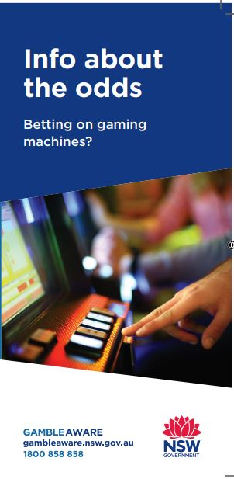 | “Info about the odds brochure”  These brochures must be prominently displayed and available in each area with gaming machines.  Translated versions are supplied to patrons from non-english speaking backgrounds upon request.  These brochures are displayed in the following locations:  • On display at the Cashier in Gaming Room
MANDATORY: CONTACT CARD 2G – Self-Exclusion Contact Card
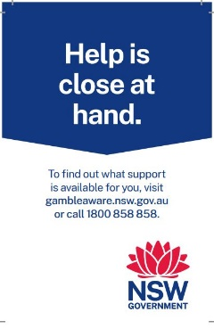 | Contact cards are securely attached to or near each bank of gaming machines in a card holder so they can be clearly seen when playing a gaming machine or approaching the bank of machines.
MANDATORY: STICKER 4G – Gambling Counselling Sticker
 | These stickers are prominently displayed on each gaming machine.
MANDATORY: PROBLEM GAMBLING MESSAGE
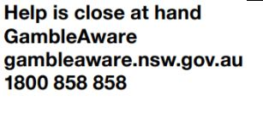 | This message is displayed in the following locations:  This message is prominently displayed on or near all ATM’s and Cash-Back Terminals.  This message is also included on any player activity statements, all betting tickets, and all gaming machine tickets.
MANDATORY: SIGN 2L – No Under 18s
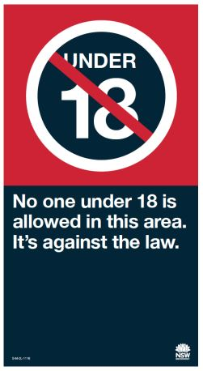 | Sign 2L (minors not permitted in this area) is prominently displayed at or close to the entrance to the restricted area in which gaming machines are kept.  This sign is displayed in the following locations:  • Displayed at the entrances to the Gaming Room

  - Player Activity Statements
Griffith Ex Servicemen's Club is required by law, to present members with a Player Activity Statement free of charge, should they request it. A Player Activity Statement show in a chosen month the player’s total amount of turnover, total wins and net expenditure, the total points earned and redeemed through the club’s rewards program as a result of playing gaming machines, the entire length of time the player’s card was inserted into gaming machines, and gambling help information. If you wish to request a player activity statement, please speak to a Duty Manager.

  - Operating Hours
Griffith Ex Servicemen's Club is permitted to operate as detailed below:
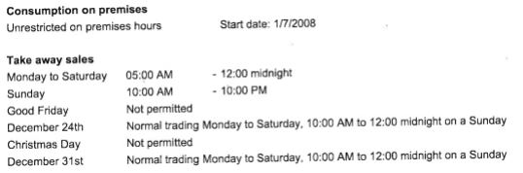
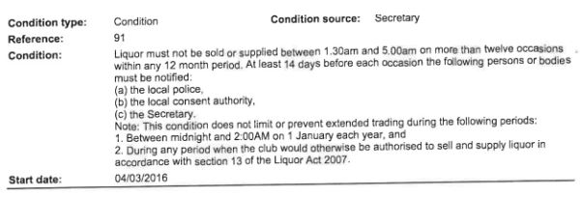

All venues are required by law to shut down their gaming floor operations for a minimum of 6 hours per 24-hour period, to facilitate machine audits and cleaning. Griffith Ex Servicemen's Club gaming machine shut down hours are identified below, meaning that gaming machines will not be operated within the times specified:
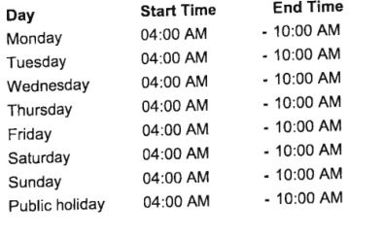

  - Gaming related licence conditions
Griffith Ex Servicemen's Club does not currently have any gaming related licence conditions in place.

  - Community Contributions
All licensed venues in NSW are required by law to return a minimum 2.25% percentage of all gambling profits to the community.
Griffith Ex Servicemen's Club contributes the required amount or above every year, through ClubGRANTS and community contributions.

  - Venue Layout
A current plan of Griffith Ex Servicemen's Club showing the gaming machine areas and surrounding areas is attached as Appendix A.

The plan indicates the location of the:
• gaming rooms
• current layout of gaming machines
• cash dispensing facilities (being ATM and CRT)

This Gaming Management Plan, for the avoidance of doubt, does not need to be updated if there is a change to:
• the gaming machine layout within the gaming areas or CRT location within the club (subject to any applicable legislative requirements); or
• a change to the location of the ATM within the non-gaming areas of the of the Club (subject to any applicable legislative requirements).

  - Review of Griffith Ex Servicemen's Club’s Gaming Plan of Management
This Gaming Plan of Management will be available to customers on the website and at the bar.

Staff must be familiar with the Gaming Plan of Management. All staff who work in the gaming room, gaming area, or with gaming machines, must regularly read this Gaming Plan of Management. Whenever there are changes to the Gaming Plan of Management, staff must read and familiarise themselves with the modified document. The Gaming Plan of Management must always be available and accessible to all staff.

Appendix C provides a list of all staff who have read the Gaming Plan of Management.

This Gaming Plan of Management will be available to all staff via email and on the staff notice board.
The operation and effectiveness of this strategy is reviewed regularly. The review process includes an opportunity for feedback from all relevantstakeholders including venue staff, customers and problem gambling support services.

Griffith Ex Servicemen's Club welcome feedback at any time, by writing to:

Mail: Kahlia Miles
Griffith Ex Servicemen's Club
12 Jondaryan Avenue
Griffith NSW 2680
Email: gaming@exies.com.au

Feedback and complaints will be recorded by Kahlia Miles. If a response is required, this will be done within fourteen days.

Anyone may make an anonymous complaint to Liquor & Gaming NSW about liquor or gaming law breaches. Complaints to Liquor & Gaming NSW can be made in the following ways:

Email: contact.us@liquorandgaming.nsw.gov.au
Phone: 1300 024 720
Website: //www.liquorandgaming.nsw.gov.au/community-and-stageholders/have-yoursay/complains/make-a-complaint

This Gaming Plan of Management must be reviewed at least annually, as well as periodically when modifications are required to reflect changes at Griffith Ex Servicemen's Club, legislative changes or emerging risks.

6.10 Local Liquor Licensing Police Contact Details
Name: Sgt Christopher Essex
Contact Number: (02) 6969 4343
Station Name: Murrumbidgee Police District – Griffith
Station Address: 41-47 Railway Street, Griffith NSW 2680
Station Telephone Number: (02) 6969 4343
Email: esse1chr@police.nsw.gov.au

This Gaming Plan of Management will be immediately produced for inspection upon request by NSW Police or L&GNSW inspectors.

- APPENDIX A – FLOOR PLAN
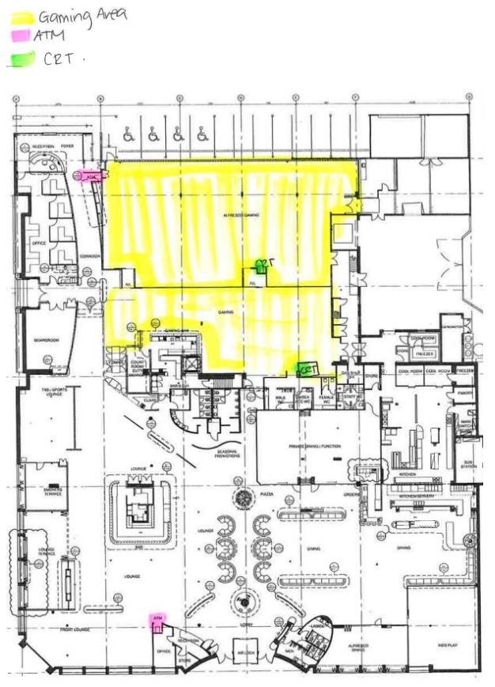

- APPENDIX B – RECORD OF STAFF COMPETENCIES
Name | Competency | Expiry Date | Verified By
- APPENDIX C – RECORD OF GPOM ACKNOWLEDGEMENT
By signing below, you acknowledge that you have read and understood the information provided in this Gaming Plan of Management.

Name | Signature | Name | Signature
- APPENDIX D – LIQUOR LICENCE
